*PhotoMet: Paper Template*

**FAst tunable single-frequency Yb-doped fiber laser**

*XX XX XX*a*, YY YY*a*, ZZZ ZZZ b, WWW WWW*a, *

aItalian Research Institute of xxx, Milan, Italy

bElectronics and Telecommunications Research Institute, yyy, zzz

*Corresponding author: aaaaa@bbbb.it

***Abstract*** − We have been developing a fast-tunable, single-frequency optical parametric oscillator (OPO) capable of emitting wavelengths between 2500 nm and 5200 nm, with the aim of achieving watt-level output for rapid remote gas sensing. To meet these performance goals, our efforts have been focused on constructing a high-power, single-frequency fiber laser at a wavelength of 1 μm with rapid tunability across 30 nm, which is intended to serve as its pump laser.

***Keywords*:** Optical Parametric Oscillator, Single-frequency, Yb-doped fiber laser, Fast tunability, Mid-Wave Infrared technology

1. **INTRODUCTION**

The significance of the mid-wave infrared (MWIR) spectral range, spanning approximately 2.5 μm to 5.2 μm, in environmental monitoring cannot be overstated [1-4]. This specific wavelength range is critical not only for the detection and analysis of gases like CO2, H2O, and NO, playing an important role in various environmental and scientific applications. Despite its importance, the application of commercial MWIR single-frequency laser sources in this field is considerably constrained by the high costs and limited wavelength tunability of currently available semiconductor lasers, such as interband cascade lasers (ICL) and quantum cascade lasers (QCL), which typically offer output powers only in the range of a few hundred milliwatts.

1. **Methods and procedures**

We have started on the development of a fiber laser, specifically employing the MOPA configuration [6]. The MOPA laser systems are composed of two key elements: a master oscillator, which is a seed laser, generates the initial laser signal with desired characteristics such as wavelength, phase, and coherence and a power amplifier that increases the output power of the seed laser from the master oscillator to higher levels without significantly altering its original properties.

The MOPA configuration makes it possible to realize high-power lasers while preserving the quality and specificity of the original signal, providing a balance between performance and control, which is not typically achievable with single-laser systems. Our designed seed laser is based on a ring resonator and utilizes an Yb-doped fiber as a gain medium, as illustrated in Figure 1.

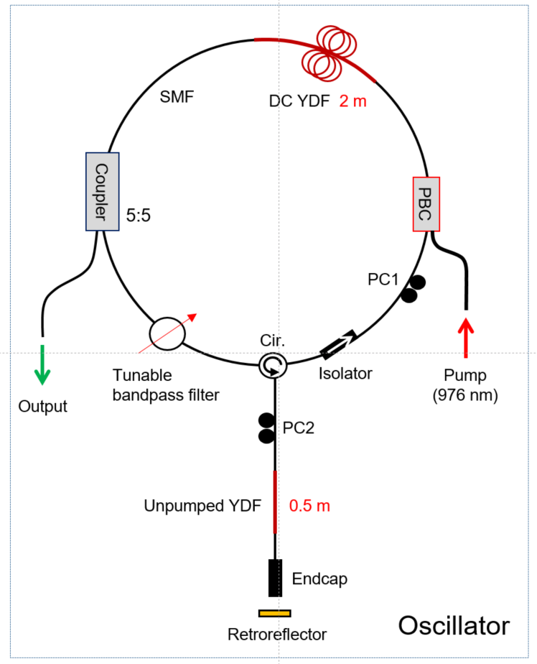

Figure 1. The seed laser configuration (SMF: single-mode fiber, DC YDF: Double-clad Yb-doped fiber, PC: Polarization controller, Cir: Circulator, PBC: Pump beam combiner)

In the all-fiber configuration of our laser system, it is essential that all fiber components in the seed laser are capable of handling tens of watts of optical power by minimizing the cavity loss. To minimize loss at the splicing points of the optical fibers, it is crucial to select fibers with similar numerical aperture (NA) and mode field diameter (MFD). For this application, we used a double-clad Yb-doped fiber of 2 meters in length. Its core MFD is approximately 7 μm and the core and cladding NA are 0.12 and 0.48, respectively. A single-mode fiber used for the cavity construction has an MFD of 6.2 μm and a core NA of 0.14. The fiber coupler in use is a 2×2 type, capable of withstanding an optical power up to 50 W, paired with an optical fiber having an NA of 0.14. The circulator and isolator in the system can withstand an optical power up to 10 W. A hollow retroreflector served as the reflector, with an end-cap type optical fiber collimator at its front that can endure an optical output power up to 15 W.

1. **Results and Discussion**

We successfully designed and constructed the seed laser and achieved output performance that satisfied our expectations. Figure 6 displays the Yb-doped fiber laser we constructed, utilizing primarily off-the-shelf optical fiber components. Our next steps include developing the post amplifier, optimizing the length of the gain fiber as well as the pump power levels to achieve an output power over 10 W. Additionally, we will assess the stability of the polarization of the laser output and, subsequently, the output power of the OPO.

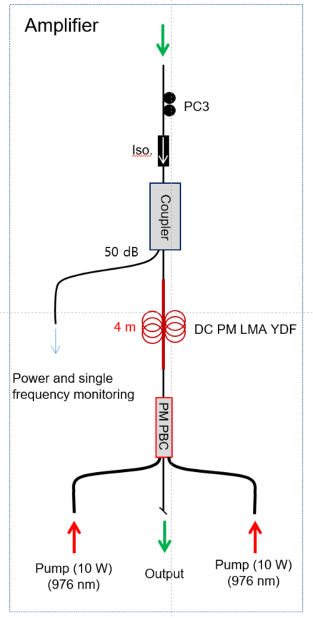

Figure 2. The amplifier configuration of the MOPA system we design. The post-amplifier of this laser system is constructed with polarization-maintaining optical fiber to ensure that the final output maintains polarization.

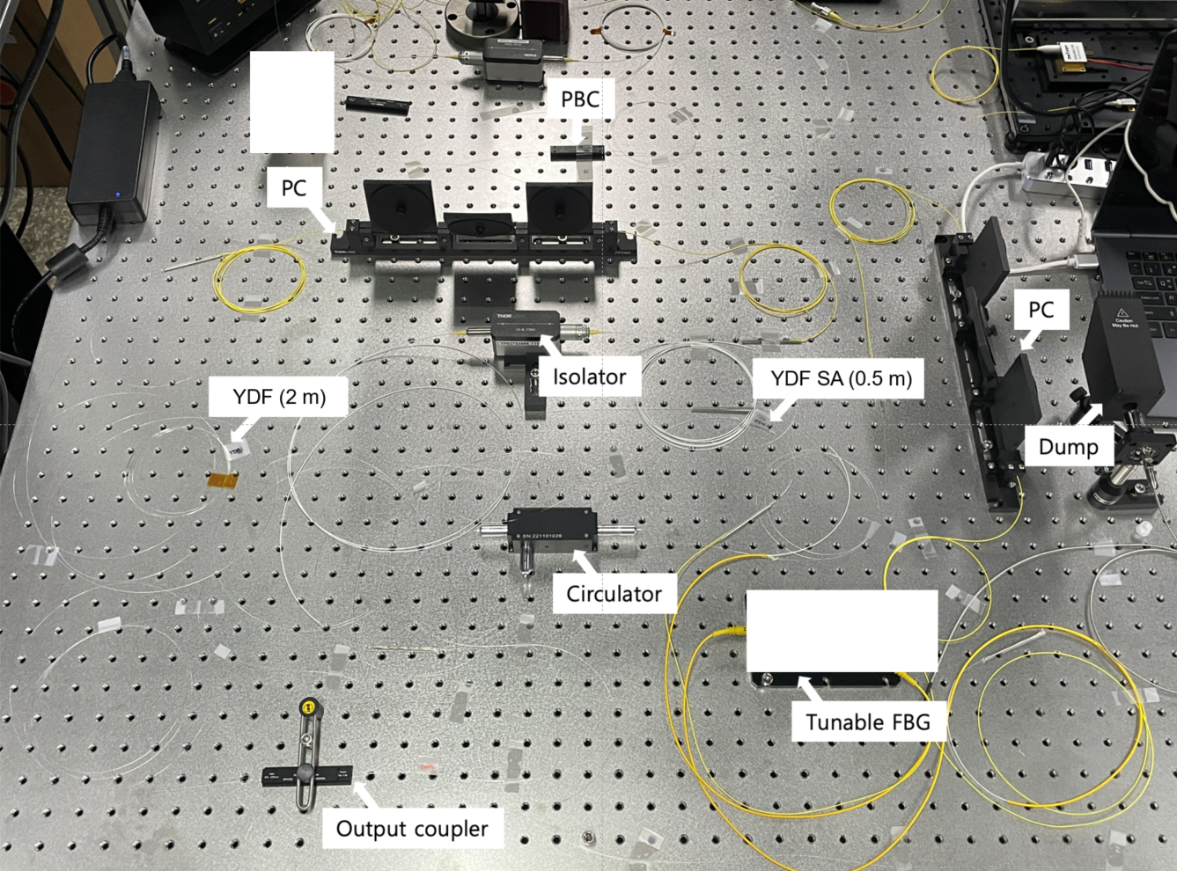

Figure 3. The seed laser we built in the laboratory.

1. **CONCLUSIONS**

Our efforts have been made in developing a watt-level, fast-tunable high-power, single-frequency fiber laser system employing a MOPA configuration. Utilizing an all-fiber approach, we carefully selected components to withstand significant optical power, focusing on NA and MFD to minimize loss at fiber splicing points. The seed laser, based on a ring resonator and utilizing a Yb-doped fiber as the gain medium, demonstrated a tunable output between 1046 nm and 1073 nm with a pump output of approximately 1.5 W. The laser threshold was observed at 1.2 W, with a slope efficiency of 133.4 mW/A, indicating efficient conversion of pump power to laser output. Anticipating an output of 1 W from the seed laser at a 9 W pump power level, our designs for a post-amplifier aim to boost this to 10 W, addressing the need for high power while maintaining the polarization quality of the output.

**ACKNOWLEDGMENTS**

Sun Do Lim and In-Ho Bae thanks Dr. Dong-Hoon Lee with KRISS and QRAD, Inc. for useful discussion about mid-IR OPOs.

This work was supported by the Institute of Information and Communications Technology Planning and Evaluation (IITP) through the Korean Government (MSIT) (Solid-State Quantum Memory) under Grant 2022-0-00198 and in part by Enhancement of Measurement Standards and Technologies in Physics through the Korea Research Institute of Standards and Science under Grant KRISS–GP2024-0002-15.

**REFERENCES**

1. Jane Hodgkinson and Ralph P Tatam, **Optical gas sensing: a review**, Meas. Sci. Technol. 24, 2012, 012004.
2. Ross Stanley, **Plasmonics in the mid-infrared**, Nature Photonics 6(7), 2009, pp. 409−411.
3. Prashant Kumar, Lidia Morawska, Claudio Martani, George Biskos, Marina Neophytou, Silvana Di Sabatino, Margaret Bell, Leslie Norford, Rex Britter, **The rise of low-cost sensing for managing air pollution in cities**, Environ. Int. 75, 2015, pp. 199−205.
4. Gabriel Ycas, Fabrizio R. Giorgetta, Esther Baumann, Ian Coddington, Daniel Herman, Scott A. Diddams & Nathan R. Newbury, **High-coherence mid-infrareddual-comb spectroscopy spanning 2.6 to 5.2μm**, Nat. Photonics 12(4), 2018, pp. 202−208.
5. In-Ho Bae, Sun Do Lim, Jae-Keun Yoo, Dong-Hoon Lee, and Seung Kwan Kim, **Development of a Mid-infrared CW Optical Parametric Oscillator Based on Fan-out Grating MgO:PPLN Pumped at 1064 nm**, Curr. Opt. Photon. 3(1), 2019, pp. 33-39.
6. Y Wang, W Ke, W Peng, Z Chang, Y Feng, Y Sun, Q Gao, Y Ma, R Zhu, C Tang. **3 kW, 0.2 nm narrow linewidth linearly polarized all-fiber laser based on a compact MOPA structure**. Laser Phys. Lett. 17, 2020, 075101.
7. Sun Do Lim, Jae-Keun Yoo, and Seung Kwan Kim, **Widely Tunable Watt-Level Single-Frequency Tm-Doped Fiber Ring Laser as Pump for Mid-IR Frequency Generation**, IEEE Photonics J. 8, 2016, 1502006.